MyThreadClass
The first program uses a lock only while printing messages. This allows all threads to run together but prevents their output from overlapping, keeping the printed messages neat and easy to read. It shows the correct way to use a lock for protecting shared resources like the console.
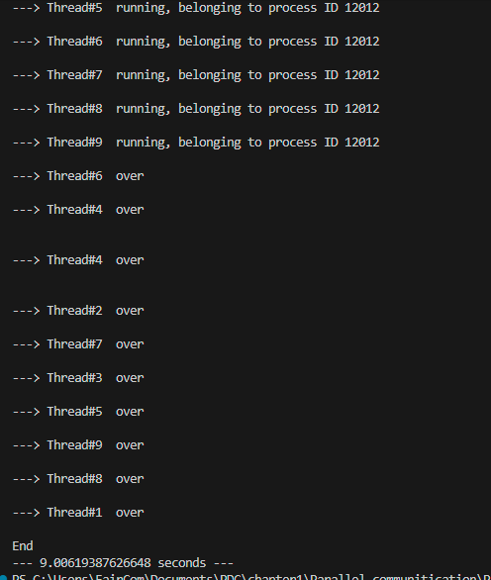

MyThreadClass_lock_2
The MyThreadClass_lock_2 uses a lock only while printing messages. This allows all threads to run together but prevents their output from overlapping, keeping the printed messages neat and easy to read. It shows the correct way to use a lock for protecting shared resources like the console.
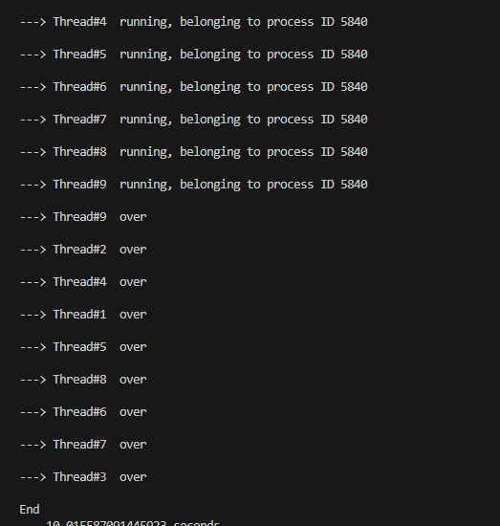

MyThreadClass_lock
The MyThreadClass_lock does not use any lock. All threads run at the same time without restrictions, which makes the program faster but can cause mixed or jumbled output. It demonstrates true parallel execution and how threads can operate independently when no synchronization is applied.
